**Screening Process for an applicant/user**

High Level Architecture

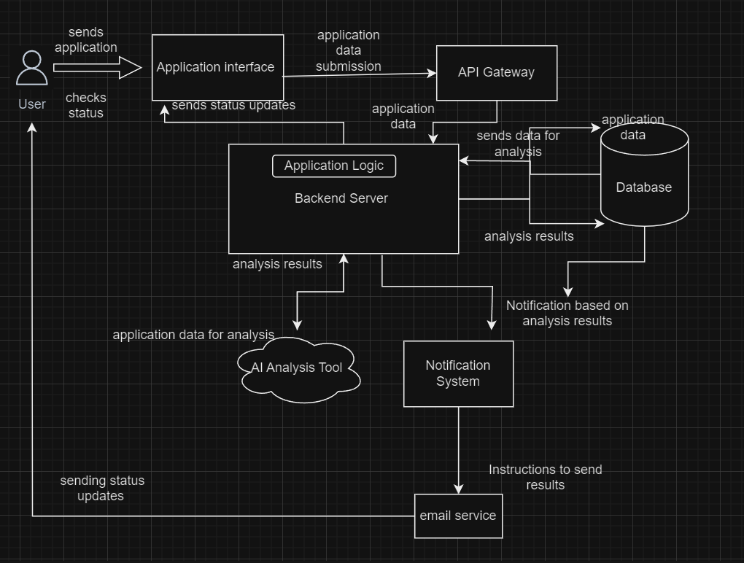

Explanation:

Application Submission : The user sends their application data to the API Gateway. The API Gateway passes the application data to the backend server.

Store Data/Retrieve Data: The backend server interacts with the Database to store and retrieve application data, analysis results.

Analyze Application: The Backend Server sends the application data to the AI Engine for analysis.

Analysis Results: The AI Engine returns the results to the Backend Server.

Send Notification: The Backend Server triggers the Notification System to email the applicant.

Email Notification: The Notification System emails the applicant regarding their application status.